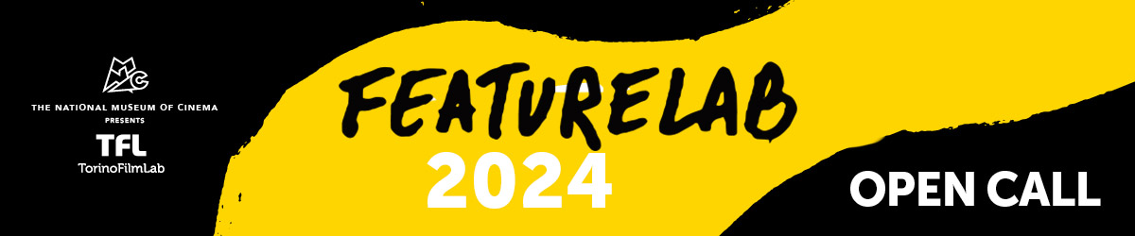
The TFL programme dedicated to 1st and 2nd feature films at advanced development stage is back for its 2024 edition.

FeatureLab is open to creative teams of director and producer (together with a scriptwriter, if on board) from all over the world. The programme is focused on film projects - fiction, creative documentaries, experimental, animation and any possible kind of cinema form - at an advanced stage of development, meaning that at least a first draft of the script in English must be presented when applying.

The 10 selected creative teams will take part in the three-workshop path starting in June 2024 and ending with the TFL Meeting Event in November, during which the participants have one-to-one meetings with market guests and the projects are assessed by an international Jury awarding production grants alongside collateral awards.

Over the course of six months, each film team will have several individual encounters with various trainers internationally experienced in the different key areas of filmmaking. Alongside having script consultations, the participants work with experts from the fields of directing, cinematography, sound, editing, but also of production, financing & sales, sustainability and audience engagement.

For more details, have a look at the call for applications over here.
DEADLINE: 11th December 2023, 2:00 pm CET
For any questions: alessia.durante@torinofilmlab.it

FeatureLab is organised by TorinoFilmLab - National Museum of Cinema with the support of Creative Europe – MEDIA Sub-programme of the European Union. Thanks to the partnerships with the Croatian Audiovisual Centre the 1st residential workshop in 2024 will take place in Croatia.

